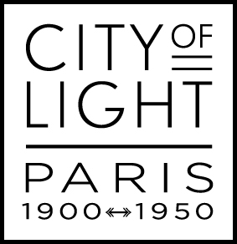 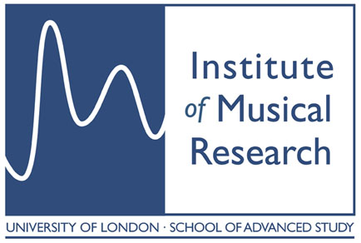

**City of Light: Paris 1900-1950**

**International Conference, 27-29 May 2015**

**Institut français du Royaume-Uni – French Cultural Institute**

17 Queensberry Place, London SW7 2DT

CALL FOR PAPERS

Organised in conjunction with City of Light: Paris 1900-1950, the Philharmonia Orchestra’s major festival of French music, this conference is held in partnership with the Institut Français du Royaume-Uni and the Institute of Musical Research (IMR) and will explore the Parisian musical and artistic milieu in the period 1900-1950. For further information about the City of Light festival see [www.philharmonia.co.uk/paris](http://www.philharmonia.co.uk/paris)

The conference aims to investigate the music of the period as well as its interactions with the visual arts, literature and the dance while considering the socio-political history that drew leading creative artists of the age to Paris from across Europe and North America. Myriam Chimènes (Director of Research, CNRS) will be the keynote speaker.

The conference concert will be given on 28 May by the Philharmonia Orchestra at the Royal Festival Hall under Principal Conductor Esa-Pekka Salonen. A lecture-recital on French piano music will be given by Paul Roberts (Guildhall School of Music and Drama) at the Institut Français on 27 May.

Bringing together researchers interested in all aspects of musical and cultural life in the French capital, the conference committee welcomes proposals that may, but need not exclusively, relate to the following topics:

Café-concert/Music-hall/Cabaret/Chanson

The place of popular culture in classical music, art and literature

Internationalism in Paris 1900-1950

Cosmopolitanism/Exoticism/ Eclecticism/Colonialism

Entente cordiale

Inter-art collaboration

Sacred-secular tension

The French flute, the French piano

Instruments and instrument makers

French musical life and education 1900-1950

Refugee artists

Exhibitions (especially 1931, 1937)

New concert spaces during the period

Music in the Parisian urban and social landscape

**PROPOSALS**

Languages of the conference will be English and French. Proposals are invited for individual 20-minute papers and should include the following:

• Title of paper and an abstract of no more than 250 words

• Short biography of the presenter (maximum 100 words)

• Institutional affiliation (where applicable)

• Postal address, telephone and email address

Proposals are particularly welcomed from postgraduate students. Thanks to the generosity of the Institut Français du Royaume-Uni, limited financial support may be available for student presenters travelling from France.

Proposals must be sent not later than **20 January 2015** as an MS Word attachment to: [**cityoflightconference@gmail.com**](mailto:cityoflightconference@gmail.com)**.**

Notification of decisions will be made via email from 20 February 2015.

**Conference committee**

Caroline Rae, Cardiff University

Caroline Potter, Kingston University London

Barbara Kelly, Keele University

Yves Balmer, Conservatoire de Paris (CNSMDP)

Christopher Murray, Université Libre de Bruxelles

Catherine Robert, Institut Français du Royaume-Uni